https://www.clayforkids.com/fused-glass/

Fused Glass
Kids Love Fused Glass – it’s Magical and Clay for Kids makes it SAFE
Safety is of utmost importance in the classroom.Softened glass with rounded edges in many shapes and colours will be used in preschool and Kindergarten classes..Grades 1-12 will have a large variety of colours, shapes and sizes of glass to chose from.

Glass programs for grades K – 12: 1½ hour classes; two classes in a day.
All classes must be in the same room due to the amount of base and decorative glass that we bring to each class and the required clean up after the classes.
Our instructor will bring all the materials to ensure the students have the opportunity to create their own fused glass masterpiece. We will demonstrate various techniques using different shapes and sizes of glass. .
Children will design their own creations as part of Art curriculum or projects such as All About Me, Insects and Nature (mountains, trees, rivers) can be tied to curriculum subjects.
When the pieces are completed, the glass will be taken to our studio to be fired. We supply all classes with information on the history and firing experience of glass. The firing process is much more complicated than with our Clay for Kids pottery pieces. We are happy to share this information with the students.
Fused glass has fit into Clay for Kids philosophy of encouraging the individual creativity of all our students whether they are children, teens or adults.
Teacher when booking glass for your students please pick from the following themes. If you have a special request we are happy to develope something new.
Fused glass Themes -

YARD ART samples can be viewed at Dr. Coffin and Glendale school
Each tile is a little over 5 cm square. The students will have a variety of coloured glass Each tile will be embedded with two wire loops which allow the tiles to be attached to the chain link fence. The decorated tiles fired and returned within 14 days.
Cost: $5/student plus GST (200 participants or more.)
8cm mini Sun Catcher – Cost: $5/student (200 participants or more)
This program has been very popular and we have delivered classes for the creation of crucifixes in many CSCD schools. Prices for Fused Glass projects are (per student, GST extra):
- Sun Catchers – $16/student. Students will learn how to embed a wire hanger into the top of their piece and see how neat it looks after the piece has been fired.
- Fused glass pendants with a bail, black cord necklace and lobster clasp – $18.00 for two pendants per student.
- Self-Portraits – $18.00.
- Crucifixes – $18.00. Simply beautiful for Easter, Christmas, Professional Development or a graduation gift.
The glass material must be ordered, pre-cut and/or prepared prior to each class. Therefore, a 50% deposit will be required upon booking for all fused glass classes.
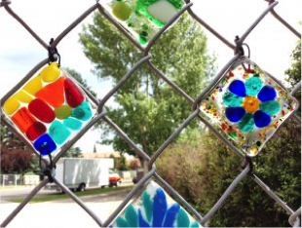
The fused glass classes were amazing. Shelley was so great with the kids and instructions were clear and easy for them to follow. All the teachers said today was great. We are looking forward to the finished product. Thank you so much from all the 3/4 teachers at Maple Ridge school.
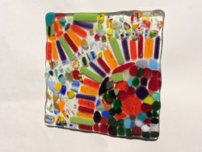new name - Abstract
Fused Glass Design
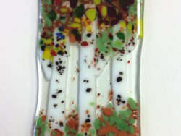
Birch Tree
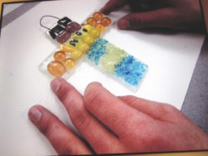
Crucifix
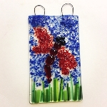
Dragonfly
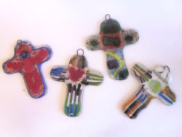replace with new photo
Crucifix

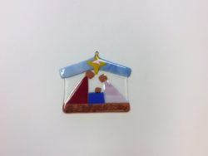replace with new photo
Nativity
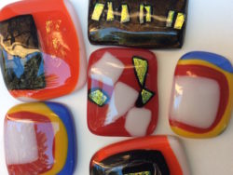
Pendants
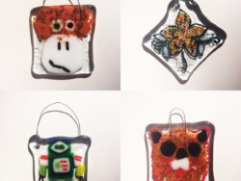
Animals
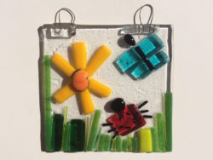
Spring Garden
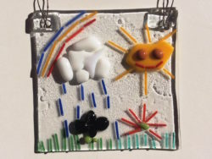
Water Cycle

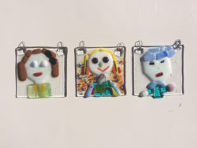eliminate
Self Portrait
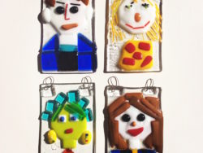
Self Portrait
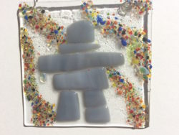
Inukshuk
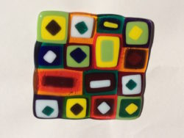
Kandinsky
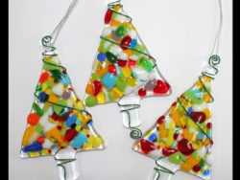
Chrismas Tree Ornaments

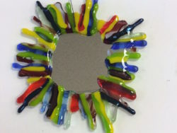
Mirror Frame
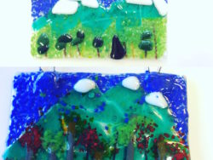
Mountains
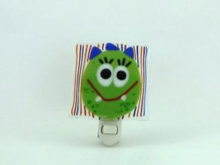Night lite
Night Lite
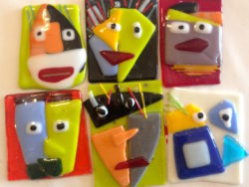
Picasso
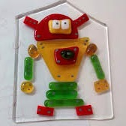
Robot

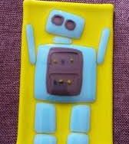
Robot
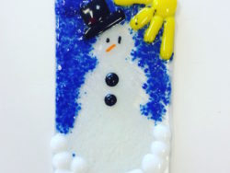
Snowman
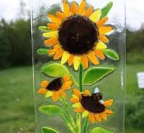eliminate
Sunflower
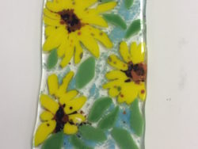
Sunflowers
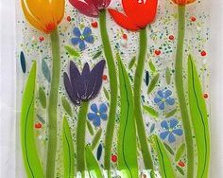
Tulip Garden

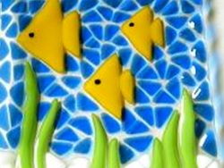eliminate
Under The Sea
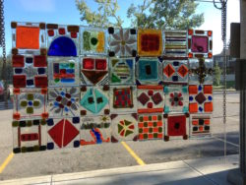
Window Art

